Title: PRenatal MOdulator Treatment to PrEvent CF ComplicaTions (PROTECT) Workshop Report

Lay Title: Summary of an interactive meeting about treating babies with CF with modulators before birth

Authors: Sylvia Szentpetery¹ and Jennifer L. Taylor-Cousar²

Affiliations:
¹ Medical University of South Carolina, Department of Pediatrics, Charleston, SC
² National Jewish Health, Departments of Internal Medicine and Pediatrics Denver, CO, USA

What was your research question?
We know that starting treatments for people with cystic fibrosis (CF) as early in life as possible is the best for their health. Right now, modulators are approved to start after birth. We wanted to discuss what is known about safety and effectiveness of using modulators before birth.

Why is this important?
When babies with CF are born, about 85% of them already have pancreatic damage and 15-20% are born with a bowel blockage that requires surgery. Data from CF animal models showed that pancreatic damage and blockage of the bowels could be prevented if modulators were given before birth. There are also some cases in people that show that treating with modulators before birth is effective for making pancreatic and bowel disease less severe. However, pregnant people were not allowed in modulator studies, and no studies were done to determine if using modulators to treat before birth was safe.

What did you do?
First, we sent a survey to doctors who take care of people with CF to ask if they were aware of the possibility of using modulators to treat before birth. Next, we invited a group of experts from around the world and mothers of children with CF to a meeting. Some of the experts presented data from animal models of pregnancy. Other experts described what is known in general about use of drugs during pregnancy and use of modulators during pregnancy. An expert from the Food and Drug Administration explained requirements for drugs to be approved for use in pregnancy.

What did you find?
Most surveyed CF doctors were aware that modulators might be safe and useful to treat before birth. Data from CF animal models showed that modulators given to pregnant animals could be effective for the fetus and did not generally cause obvious harm to pregnant animals or the fetus. In people, vital organs develop during the 3rd-8th weeks, but most studies do not allow pregnant females, so we do not know enough about safety of drugs during pregnancy. In cases of babies treated before birth, the majority were more healthy at birth after they received modulators through their pregnant mother.

What does this mean and reasons for caution?
Data from CF animal models and the small number of cases in humans when modulators were used before birth suggests this treatment might be safe and effective. However, there were no formal studies in humans to show that it is safe and effective to use modulators before birth. Also, we do not yet know the best dose or the best time to start modulators during pregnancy. Finally, because modulators are not approved during pregnancy, insurance companies sometimes will not cover modulators for pre-birth treatment. The FDA has specific requirements for testing new drugs in people who are pregnant and/or breastfeeding.

What’s next?
We are creating educational materials for doctors and families that explain what is known about obtaining and using modulators to treat before birth. To better understand timing, dosing and safety of using modulators before and after birth, we are collecting data from cases. We are also designing a research study.

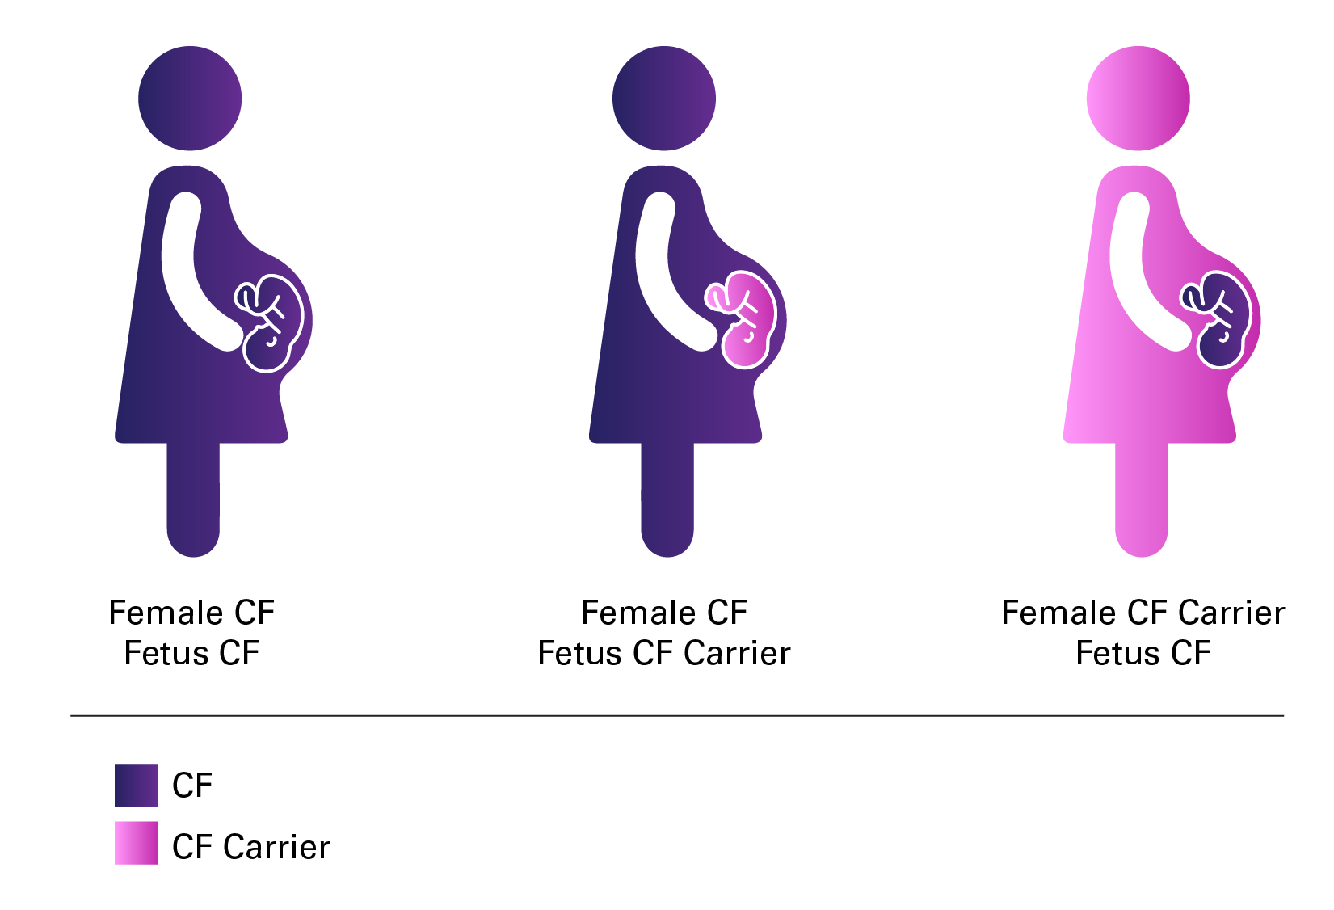
Figure legend: three ways a fetus may be exposed to modulators that are given to the pregnant female.

Original manuscript citation in PubMed
https://pubmed.ncbi.nlm.nih.gov/40754574/

