Title:
Symptom Factors and Their Clinical Correlates Among Adults with Cystic Fibrosis

Lay Title:
Understanding Symptom Patterns in Adults with Cystic Fibrosis

Authors:
Natalia Smirnova MD MSc, Scott Gillespie MS MSPH, Jane Lowers PhD, Andrew Jergel MPH, Elisabeth P Dellon MD MPH, Alexandre Cammarata-Mouchtouris PhD MSc, Anne Fitzpatrick PhD, Dio Kavalieratos PhD FAAHPM

Affiliations:
Emory University, University of North Carolina at Chapel Hill

What was your research question?
Can we group common symptoms in adults with cystic fibrosis (CF) into meaningful patterns, and what personal or health-related factors are linked to these symptom patterns?

Why is this important
Even with new treatments like CFTR modulators that improve lung health and extend life, many adults with CF still experience multiple symptoms that affect their daily lives. These symptoms often happen together and may be related. Understanding how symptoms group together—and what contributes to these patterns—can help providers treat people more holistically. This study also looked at how factors like age, financial stress, and lung health are linked to more severe symptoms. This can help identify people who may need extra support.

What did you do?
We studied 262 adults with CF who had ongoing symptoms. Using a detailed symptom questionnaire, we grouped related symptoms using a method called factor analysis. We found three main symptom groups. Then, we looked at which life or health characteristics were linked to having more severe symptoms in each group.

What did you find?
We found three groups of related symptoms:
- Respiratory-Energy (e.g., cough, shortness of breath, fatigue)
- Mood–Gastrointestinal Irritability (e.g., anxiety, sadness, bloating, diarrhea)
- Pain–Gastrointestinal Dysmotility (e.g., pain, poor appetite, nausea, constipation)
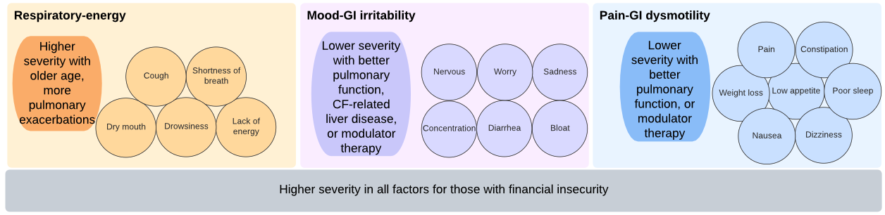
Older age, more lung flares, and financial insecurity were linked to more severe symptoms in the respiratory-energy group. People on CFTR modulators had fewer respiratory and pain-related symptoms, but not mood-related symptoms.

What does this mean and reasons for caution?
Treating one symptom at a time may not be enough—symptoms often come in groups and can make each other worse. For example, managing fatigue may also mean addressing cough and breathlessness. Mental health and gut symptoms were closely linked and may benefit from joint treatment. Social factors like financial stress were linked to worse symptoms, highlighting the need for whole-person care. However, this study was done at a single point in time, so we don’t know how symptoms change over time. More research is needed to confirm these patterns and understand why they occur.

What’s next?
Future research should explore how these symptom groups change over time and test whether using them in clinical care can help personalize treatment and improve well-being for people with CF.

Original manuscript citation in PubMed
https://pubmed.ncbi.nlm.nih.gov/40628572/

