How to use My ECFS as an ECFS member.
This user guide has been developed to support our members in accessing all the MY ECFS features which are available to current members via www.ecfs.eu
- The first step is to click on ‘LOG IN’ on the top right-hand tab as seen below:
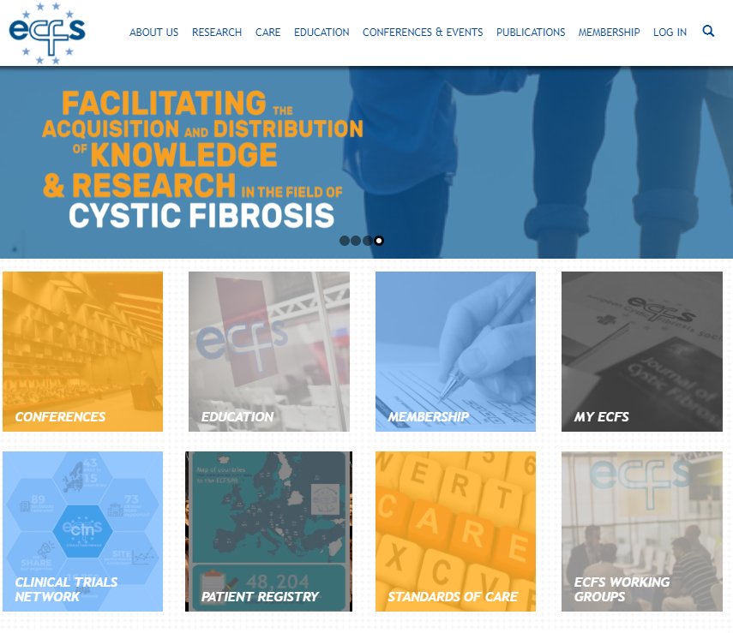
- For those who have already created a profile and/or purchased an ECFS subscription, enter your unique username or e-mail address, password and the CAPTCHA code printed in the spaces provided. If you have forgotten your password, please click on the ‘Request new password’ tab.
- For those who are new to ECFS, please click on the ‘Create new account’ tab and input your details on the spaces provided.
For returning users:
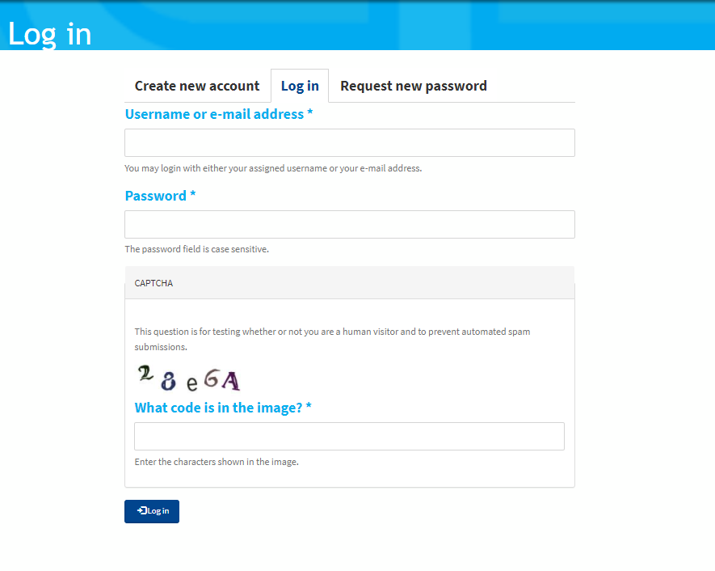

For new users:
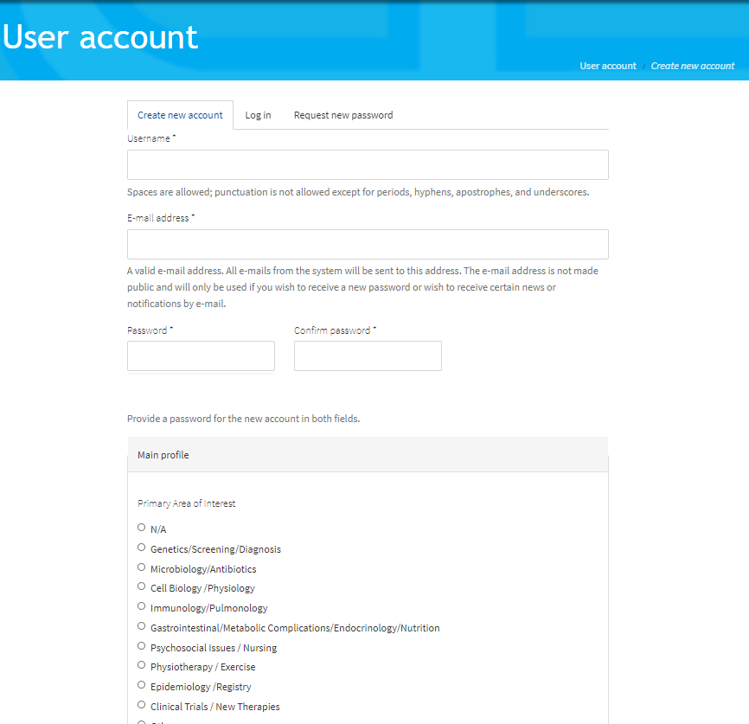
- By logging in, or creating a new profile, you will automatically be taken to the following page:
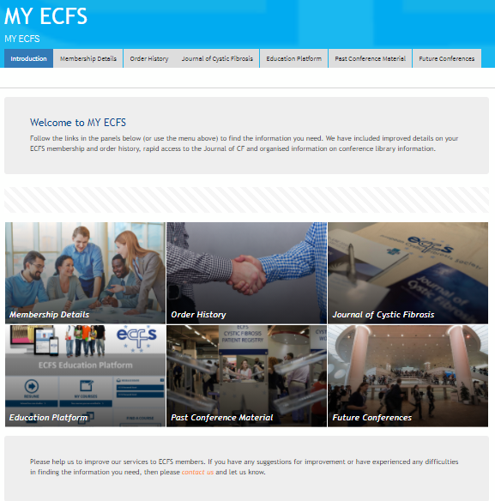

Please note: once you have logged in, you can also access MY ECFS at any time from the homepage by clicking on the ‘MY ECFS’ icon as shown below:
OR
By clicking on ‘info’ next to your name on the top right-hand side of the page:
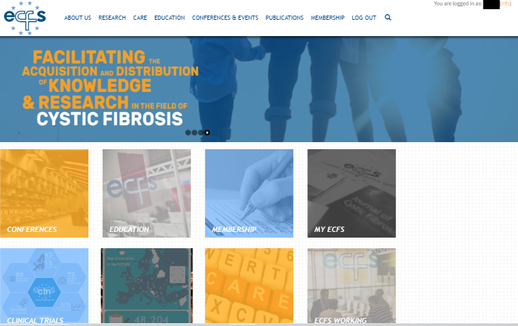

MY ECFS
- As an ECFS member, you can access all the features of MY ECFS. There are two ways to access these features: either by clicking on the tabs on the bar or by clicking on the icons as shown below:
- Membership details: allows you to view or edit your ECFS account details such as address details, name and email address. You can also view your current ECFS membership subscription on this tab as well as your unique membership number.
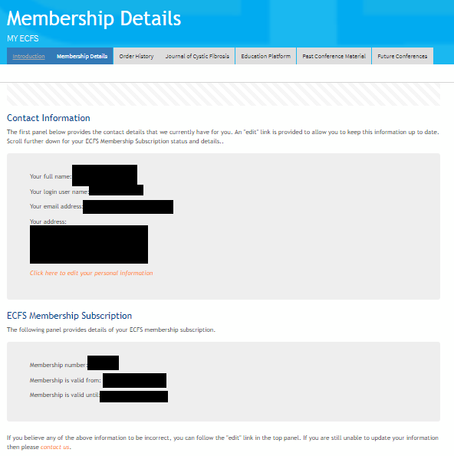
- Order history: allows you to view all the past and current orders you have placed with ECFS (including membership subscriptions and Basic Science conference registrations). You can use this feature to generate invoices or receipts.
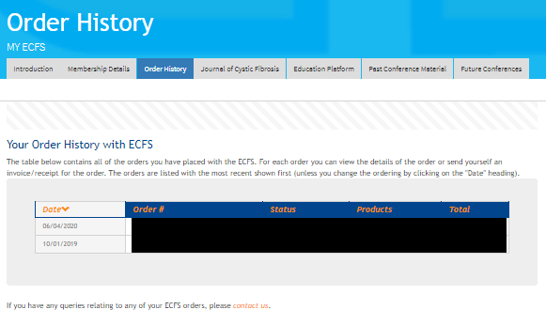
- Journal of CF: access to the JCF (only for full and corporate membership subscriptions). Your unique Elsevier JCF Customer Reference number is also shown.
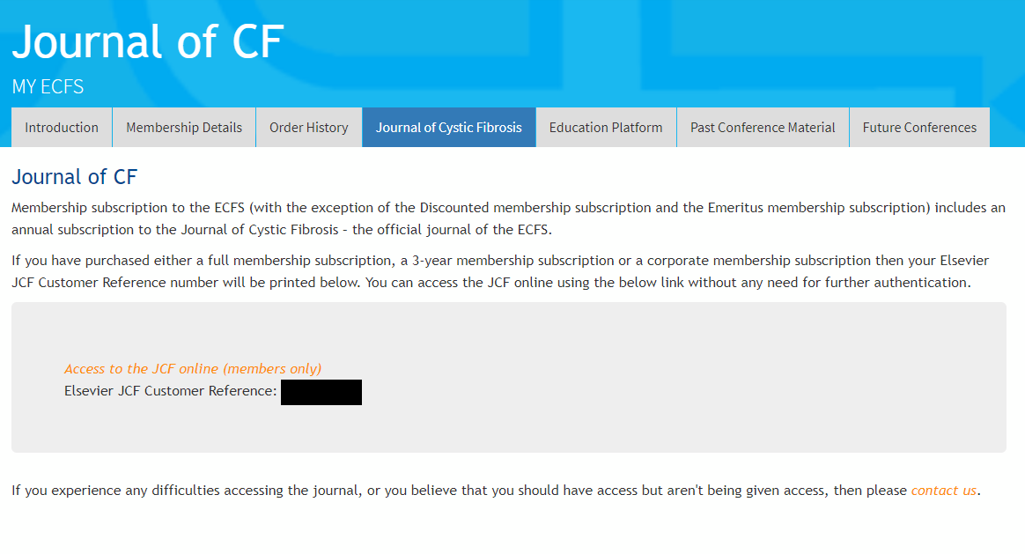
- Education Platform: contains ECFS courses and selected webcasts from previous ECFS conferences (pre-conference courses, plenaries, symposia and satellite symposia) and meetings. The Education Platform is available to current ECFS members (except corporate members from the industry) and those who have purchased an Education Platform Token.
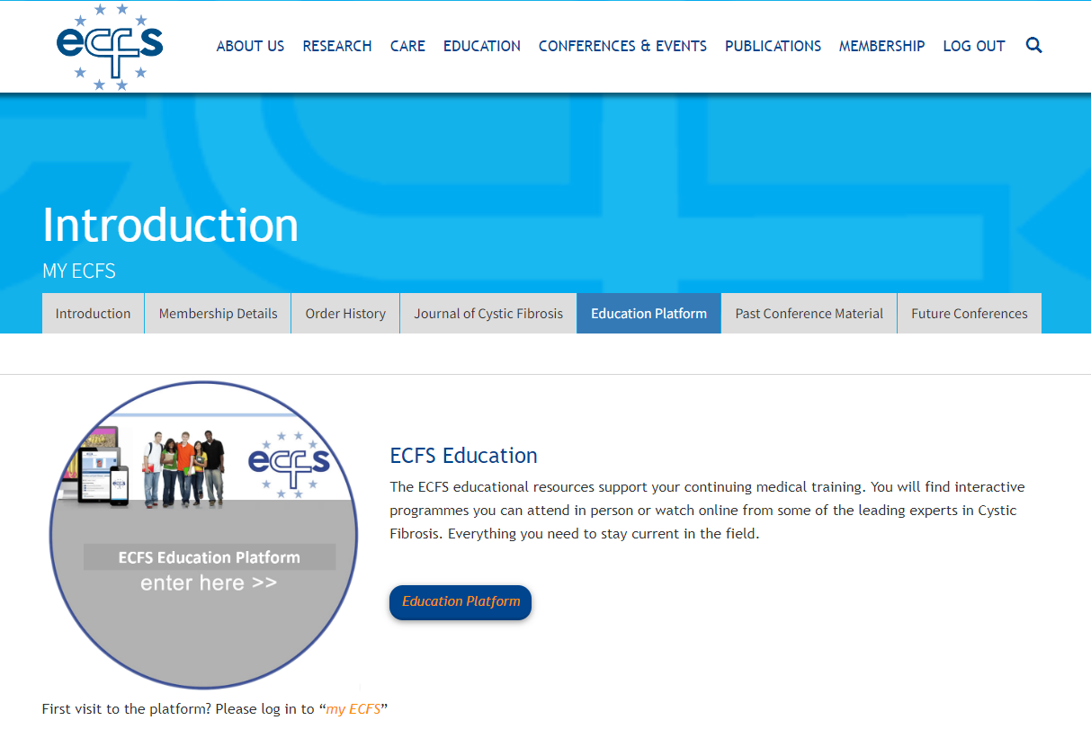
- Past Conference Material: direct access to past conference links and presentations.
- Future Conferences: access to future ECFS conferences.

ECFS Education Platform
To access the Education Platform:
- Please log into your ECFS account (as instructed on page 1 of this document) and then click on the education platform icon on MY ECFS.
The Platform can also be accessed on the education homepage (www.ecfs.eu/education) and by clicking on either of the education platform buttons, as shown below.

- You will then be taken to your home page.
- To view ECFS courses, webcasts from previous ECFS conferences (pre-conference courses, plenaries, symposia) and meetings on the ECFS Education Platform, click on ‘ECFS Courses, Conferences and Meetings’:

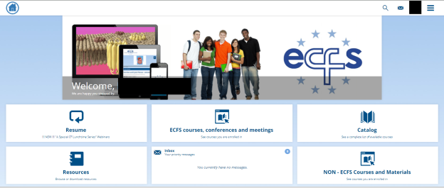

- To view non- ECFS courses and materials (which includes industry satellite symposia from ECFS conferences), click on ‘NON-ECFS Courses and Materials’
- Resume: Allows you to continue the educational material you last viewed
- Catalog: Contains a complete list of available ECFS and Non-ECFS educational material
- Resources: Contains resources which you are able to browse or download e.g., CF and CFTR related websites, Mental Health Working Group dedicated website, and Standards of Care documents. Those affiliated to the CTN (e.g., PIs, sub-I’s, study coordinators, research nurses etc) also have access to the CTN SOPs and Patient Information Leaflets.
- Inbox: Contains messages sent to you about course enrolments.

‘ECFS Courses, Conferences and Meetings’
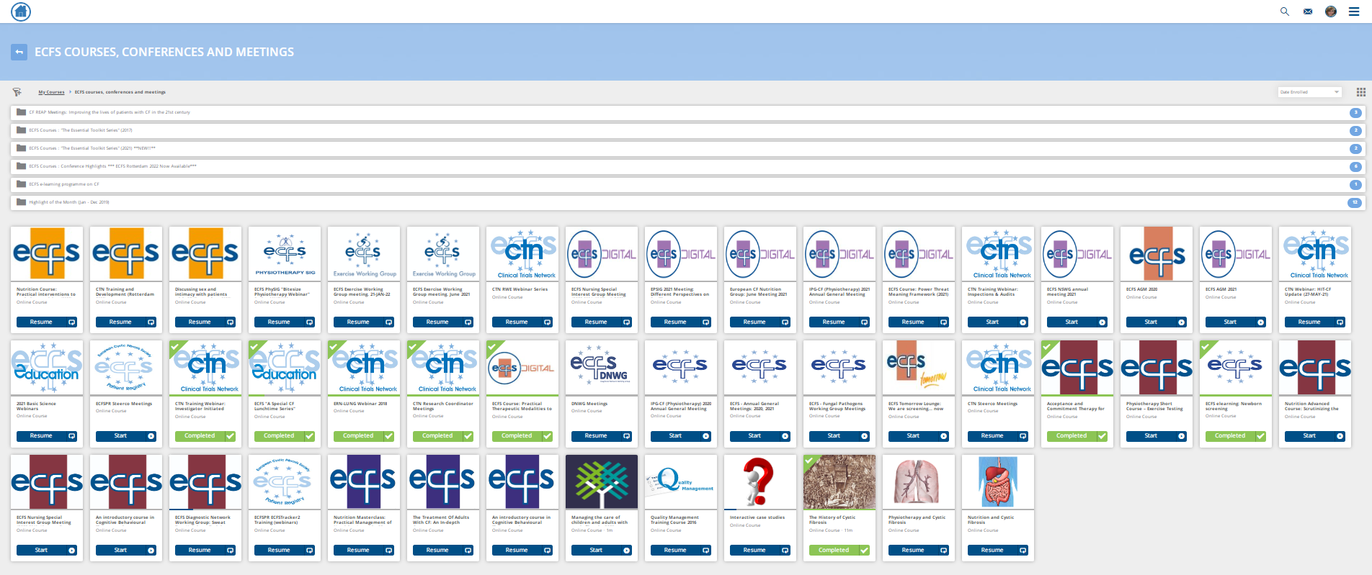
Within this section, there are several folders and individual tiles for various educational resources (see image below):

Folders
The folders at the top of the page contain resources from the same event or topic e.g., webcasts and selected talks from the past five European CF conferences (2017-2022), The ‘Essential Toolkit Series’ courses held in 2017 (Seville) and 2021 (online), the ECFS e-learning programme on CF (Part 1), CF REAP meetings (held in 2018 and 2019 on various topics), etc.

Tiles
The individual tiles (below the folders) contain:
- Recordings of the “A Special CF Lunchtime Series” webinars (2020, 2021 and 2022)
- Recordings of the ECFS Physiotherapy Special Interest Group (PhySIG) "Bitesize Physiotherapy Webinar" Series (2022)
- Recordings of the 2021 Basic Science webinars (held in April and July)
- Various meetings from the ECFS projects (e.g., CTN, Registry) and working groups (e.g., Exercise, Nursing Mental Health, Diagnostic Network etc)
- Various pre-conference courses e.g., Nutrition Course: Practical interventions to optimise nutrition (2022), Discussing sex and intimacy with patients with CF (2022), Power, Threat, Meaning Framework (2021), Nutrition Advanced Course: Scrutinizing the future for Nutrition in Cystic Fibrosis (2020), Practical Therapeutic Modalities to manage anxiety, depression, sleep and pain in routine CF care (2020), Acceptance and Commitment Therapy (2019), Physiotherapy Short Course – Exercise Testing in Cystic Fibrosis – Who, When and Why? (2019), Nutrition Masterclass: Practical Management of Nutrition Issues in CF (2018), etc
- Interactive case studies from European CF conferences (2017, 2018, 2019)
- Recordings of the Annual General Meeting (AGM) from the 2020 and 2021 ‘ECFS Digital’ conferences
- ECFS Tomorrow Lounge: We are screening... now what? Different treatment modalities in CF mental health (2020)
- The History of CF (short review of the early history of CF)
- And much more!

